|  |  |  |  |  |  |
| --- | --- | --- | --- | --- | --- |
| Date | 29-Nov-22 | | | Tester Name | Andrew McLaughlin |
| Environment | Penfax - Test 2 | | | Login used | <If different from the Tester> |
| Operating System | Windows | Version: 21H1 | Update Number: | | |
| Software Used | Select Software | Version: 107.0.1418.56 | Update Number: | | |
| Select Software | Version: | Update Number: | | |
| Application Release version | R22.4.1 | | | | |
| Test Case Title | E16.31b | | | | |
| Test Type | Regression | | | | |
| Test Scenario | Process VPB lump sum payment via wire transfer | | | | |
| Expected Results | The wire transfer will process correctly | | | | |
| Pass/Fail | Select | | | JIRA# | <enter the new JIRA ticket number if the test case failed> |

Find a member with a wire transfer fee

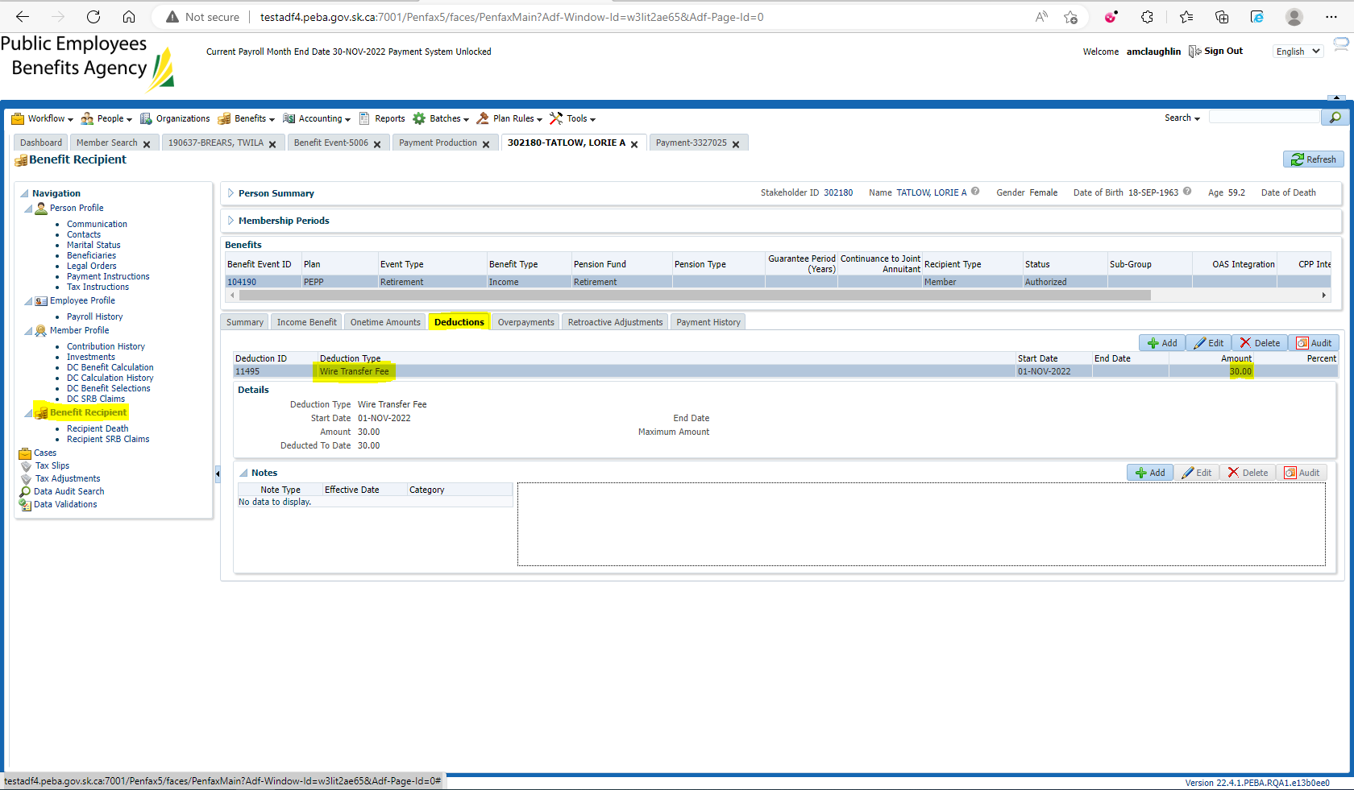

Check their Payment Information after payroll runs to verify that the wire transfer fee has been deducted properly